Faizal Wahyu Nuramdhan  
L200180011

TUGAS MODUL 4

**Percobaan 1 : Substitusi Pengganti Gerbang Logika**

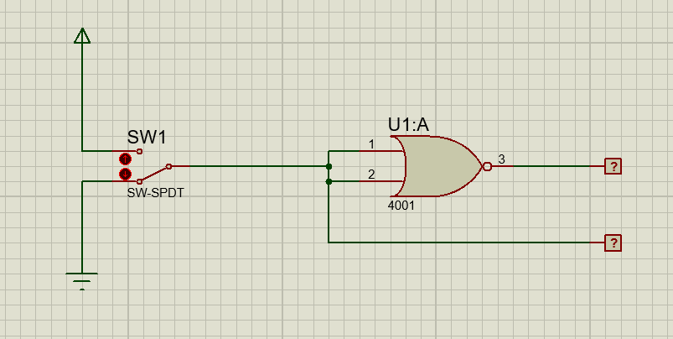

Fungsi Boolean : L1 = L2 + L2 = L2

Tabel kebenaran

|  |  |  |
| --- | --- | --- |
| **SW 1** | **L2** | **L1** |
| 0 | 0 | 1 |
| 1 | 1 | 0 |

Diagram waktu

|  |  |
| --- | --- |
|  | **1** |
| **0** |  |

L2

|  |  |
| --- | --- |
| **1** |  |
|  | **0** |

L1

Kesimpulan : Gerbang NOR Gambar 4.3 membentuk logika dari gerbang **NOT**

**Percobaan 2 : Substitusi Pengganti Gerbang** **Logika**

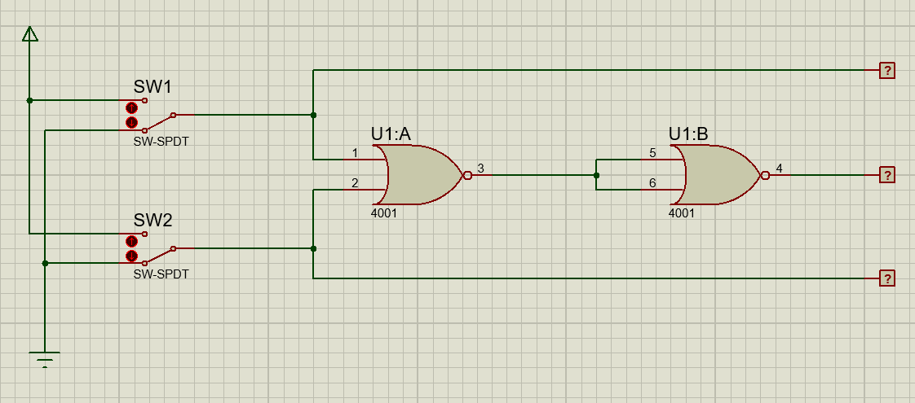

**Fungsi Boolean : L3 = L1 + L2 = L1 + L2**

Tabel kebenaran

|  |  |  |  |  |
| --- | --- | --- | --- | --- |
| **SW 1** | **SW 2** | **L1** | **L2** | **L3** |
| 0 | 0 | 0 | 0 | 0 |
| 1 | 0 | 1 | 0 | 1 |
| 0 | 1 | 0 | 1 | 1 |
| 1 | 1 | 1 | 1 | 1 |

Diagram waktu

|  |  |  |  |
| --- | --- | --- | --- |
|  | **1** |  | **1** |
| **0** |  | **0** |  |

L1

|  |  |  |  |
| --- | --- | --- | --- |
|  |  | **1** | **1** |
| **0** | **0** |  |  |

L2

|  |  |  |  |
| --- | --- | --- | --- |
|  | **1** | **1** | **1** |
| **0** |  |  |  |

L3

Kesimpulan : Gerbang NOR Gambar 4.4 membentuk logika dari gerbang **OR**

**Percobaan 3 : Substitusi Pengganti Gerbang** **Logika**

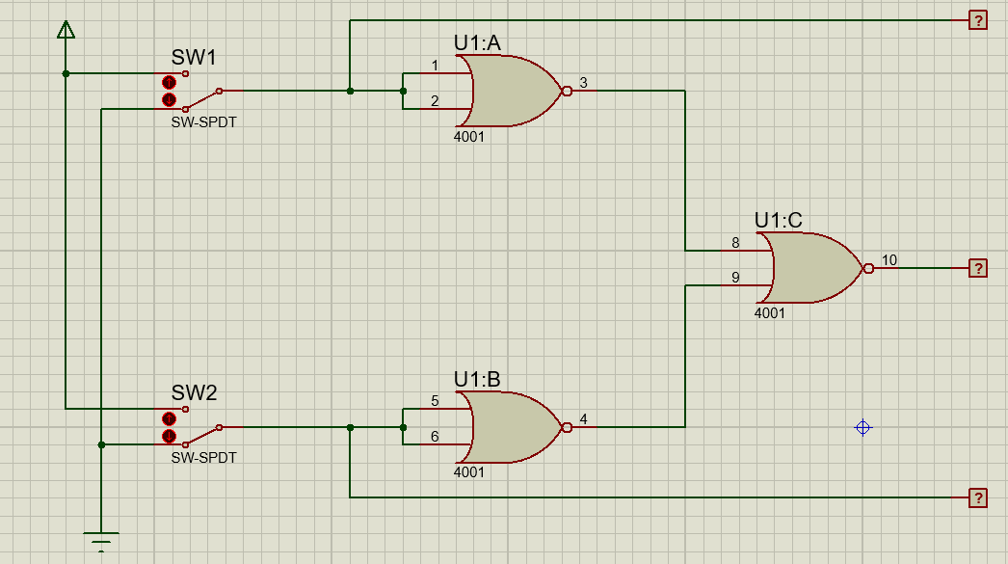

**Fungsi Boolean : L3 = L1 + L2 = L1L2**

Tabel kebenaran

|  |  |  |  |  |
| --- | --- | --- | --- | --- |
| **SW 1** | **SW 2** | **L1** | **L2** | **L3** |
| 0 | 0 | 0 | 0 | 0 |
| 1 | 0 | 1 | 0 | 0 |
| 0 | 1 | 0 | 1 | 0 |
| 1 | 1 | 1 | 1 | 1 |

Diagram waktu

|  |  |  |  |
| --- | --- | --- | --- |
|  | **1** |  | **1** |
| **0** |  | **0** |  |

L1

|  |  |  |  |
| --- | --- | --- | --- |
|  |  | **1** | **1** |
| **0** | **0** |  |  |

L2

|  |  |  |  |
| --- | --- | --- | --- |
|  |  |  | **1** |
| **0** | **0** | **0** |  |

L3

Kesimpulan : Gerbang NOR Gambar 4.5 membentuk logika dari gerbang **AND**

**Percobaan 4 : Substitusi Pengganti Gerbang Logika**

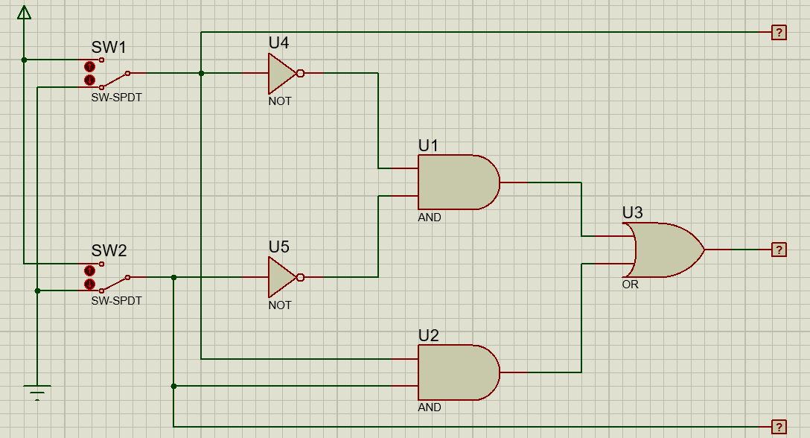

**Fungsi Boolean : L3 = L1L2 + L1L2 = L1 L2**

Tabel kebenaran

|  |  |  |  |  |
| --- | --- | --- | --- | --- |
| **SW 1** | **SW 2** | **L1** | **L2** | **L3** |
| 0 | 0 | 0 | 0 | 1 |
| 1 | 0 | 1 | 0 | 0 |
| 0 | 1 | 0 | 1 | 0 |
| 1 | 1 | 1 | 1 | 1 |

Diagram waktu

|  |  |  |  |
| --- | --- | --- | --- |
|  | **1** |  | **1** |
| **0** |  | **0** |  |

L1

|  |  |  |  |
| --- | --- | --- | --- |
|  |  | **1** | **1** |
| **0** | **0** |  |  |

L2

|  |  |  |  |
| --- | --- | --- | --- |
| **1** |  |  | **1** |
|  | **0** | **0** |  |

L3

Kesimpulan : Gerbang pada Gambar 4.6 membentuk logika dari gerbang **XNOR**

**Percobaan 5 : Merancang Fungsi Boolean ke dalam rangkaian**

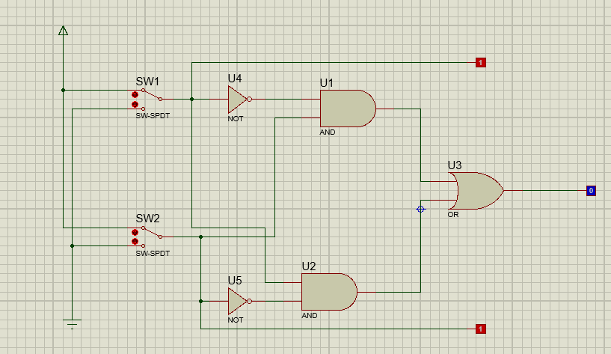

**Fungsi Boolean : L3 = L1L2 + L1L2 = L1 L2**

Tabel kebenaran

|  |  |  |  |  |
| --- | --- | --- | --- | --- |
| **SW 1** | **SW 2** | **L1** | **L2** | **L3** |
| 0 | 0 | 0 | 0 | 0 |
| 1 | 0 | 1 | 0 | 1 |
| 0 | 1 | 0 | 1 | 1 |
| 1 | 1 | 1 | 1 | 0 |

Diagram waktu

|  |  |  |  |
| --- | --- | --- | --- |
|  | **1** |  | **1** |
| **0** |  | **0** |  |

L1

|  |  |  |  |
| --- | --- | --- | --- |
|  |  | **1** | **1** |
| **0** | **0** |  |  |

L2

|  |  |  |  |
| --- | --- | --- | --- |
|  | **1** | **1** |  |
| **0** |  |  | **0** |

L3

Kesimpulan : Kombinasi gerbang akan membentuk logika dari gerbang **XOR**